# Mockito Hands-On Exercises

## Exercise 1: Mocking and Stubbing

### Scenario:

You need to test a service that depends on an external API. Use Mockito to mock the external API and stub its methods.

### Steps:

1. Create a mock object for the external API.

2. Stub the methods to return predefined values.

3. Write a test case that uses the mock object.

### Solution Code:

MyService.java

public class MyService {  
 private ExternalApi api;  
  
 public MyService(ExternalApi api) {  
 this.api = api;  
 }  
  
 public String fetchData() {  
 return api.getData();  
 }  
}  
  
interface ExternalApi {  
 String getData();  
}

MyServiceTest.java

import static org.mockito.Mockito.*;  
import static org.junit.jupiter.api.Assertions.*;  
import org.junit.jupiter.api.Test;  
import org.mockito.Mockito;  
  
public class MyServiceTest {  
 @Test  
 public void testExternalApi() {  
 ExternalApi mockApi = Mockito.mock(ExternalApi.class);  
 when(mockApi.getData()).thenReturn("Mock Data");  
 MyService service = new MyService(mockApi);  
 String result = service.fetchData();  
 assertEquals("Mock Data", result);  
 }  
}

## MyService.java

public class MyService {

private ExternalApi api;

public MyService(ExternalApi api) {

this.api = api;

}

public String fetchData() {

return api.getData();

}

}

interface ExternalApi {

String getData();

}

## Output

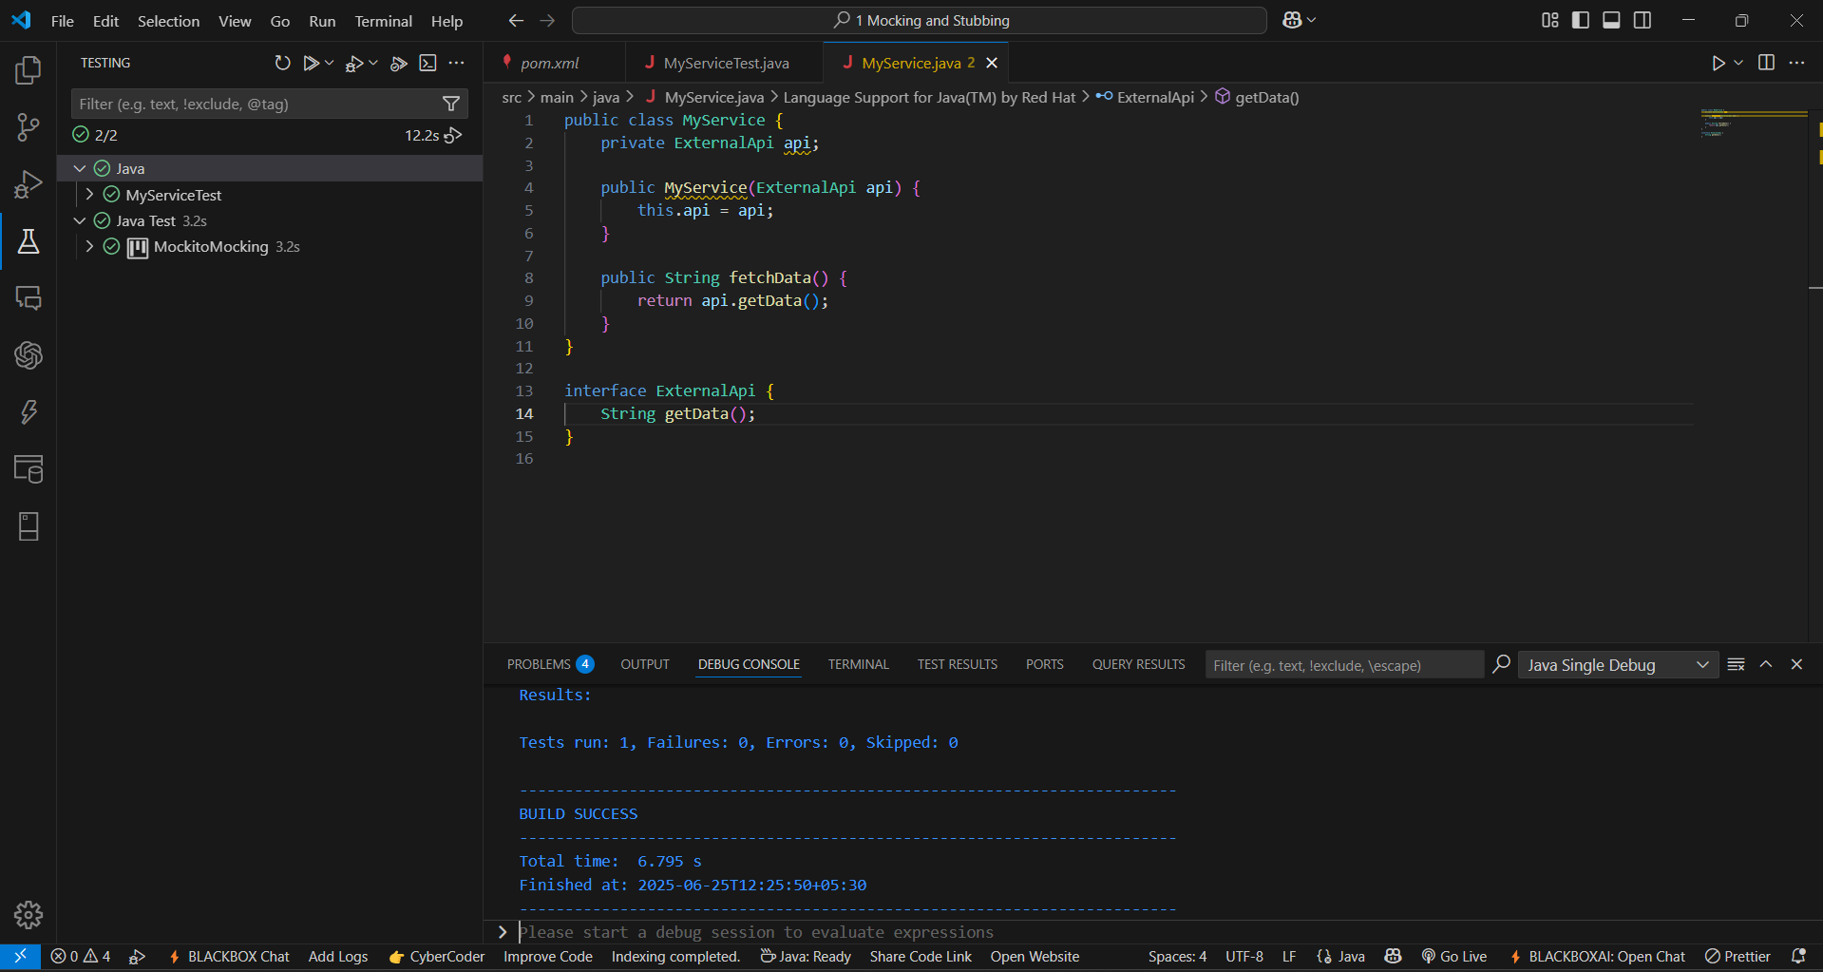

## Exercise 2: Verifying Interactions

## Scenario:

You need to ensure that a method is called with specific arguments.

## Steps:

1. Create a mock object.

2. Call the method with specific arguments.

3. Verify the interaction.

## Solution Code

import static org.mockito.Mockito.*;

import org.junit.jupiter.api.Test;

import org.mockito.Mockito;

public class MyServiceTest {

@Test

public void testVerifyInteraction() {

ExternalApi mockApi = Mockito.mock(ExternalApi.class);

MyService service = new MyService(mockApi);

service.fetchData();

verify(mockApi).getData();

}

}

## MyService.java

public class MyService {

private ExternalApi api;

public MyService(ExternalApi api) {

this.api = api;

}

public String fetchData() {

return api.getData();

}

}

interface ExternalApi {

String getData();

}

## MyServiceTest.java

import static org.mockito.Mockito.*;

import static org.junit.jupiter.api.Assertions.*;

import org.junit.jupiter.api.Test;

import org.mockito.Mockito;

public class MyServiceTest {

@Test

public void testVerifyInteraction() {

ExternalApi mockApi = Mockito.mock(ExternalApi.class);

MyService service = new MyService(mockApi);

service.fetchData();

verify(mockApi).getData();

}

}

## Output

